

Work-Study Counter

Gandy Dominguez

Daniel Rodriguez

Juan Bosco Torrez

Keiser University

Final Project Documentation

Carolina Carvajal

April 21th, 2019

**Table of Contents**

**Introduction** **3**

**List of Requirements** **4**

**ERD Diagram** **5**

**Data Dictionary** **6**

**Development Components Diagram** **9**

**Implementation Diagram** **10**

**Relevant things about code** **11**

**Required instructions for installation** **12**

**General recommendations for system maintenance** **13**

**Conclusions** **14**

## Introduction

The idea of this project was born because of the student’s necessity for an automatized process. The current systems have presented flaws over the years. Work-study hours sheets have been misplaced or even lost. Students who have to turn the sheets to the Human Resources office most of the times forget about the deadline, which deducts them 5% of the total amount of worked hours. The primary purpose of this project is to eradicate all those issues that might entail consequences to them. We focus on creating something that will be easy to use and to interact with it. The project can be used by everyone no matter its age; it is easy to read and to access. The project purpose is to let the students feel confident that their hours will be delivered on time; there will be no deduction of the hours. In addition, the website will provide a newsletter where students can be notified of the job openings and activities held by the department.

## List of Requirements

**Student View**

1. Log in into the Student Section.
2. Stop-Watch that saves the amount of worked hours
3. A tap where you can see the excel format of the monthly worked hours
4. access to the newsletter

**Manager View**

1. Log in into the Manager Section
2. Know the students status (which students are logged in)
3. Manage the students’ data and monthly reports
4. add, edit and delete students information
5. Be able to post in the newsletter

## ERD Diagram

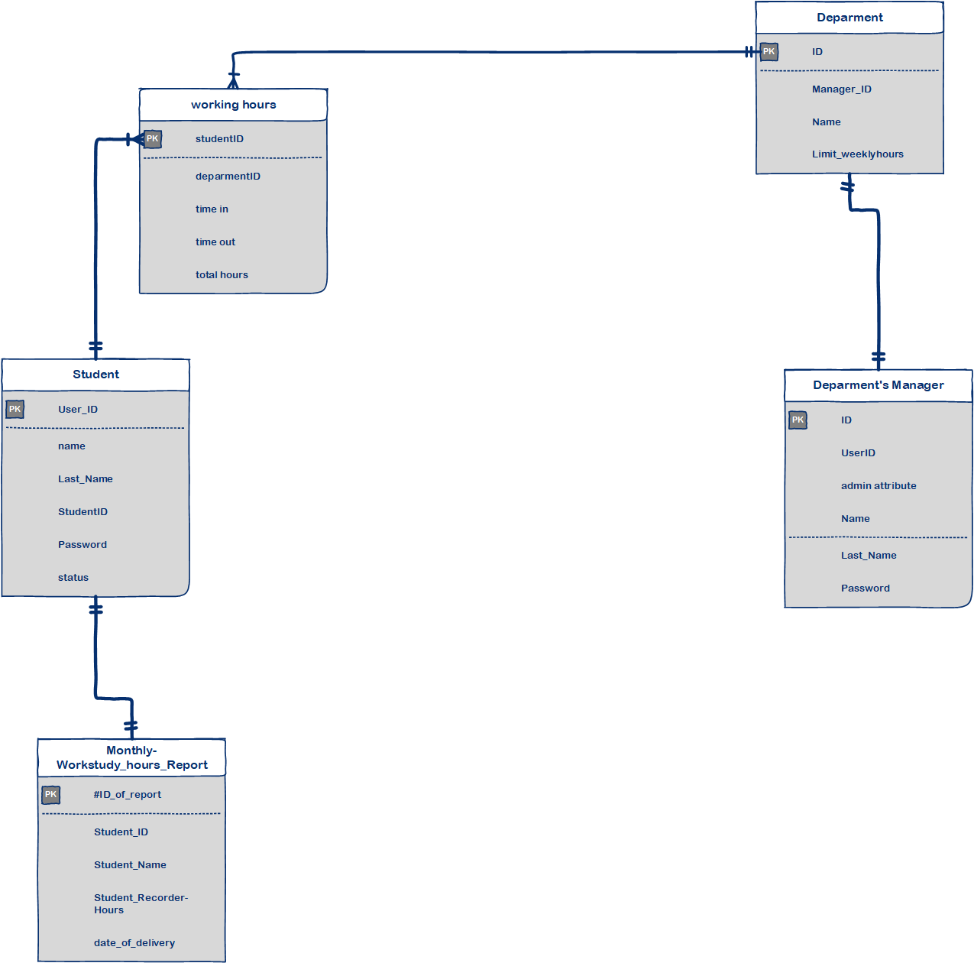

## Data Dictionary

|  |  |
| --- | --- |
| **Table** | **Column** |
| **Login** | **ID** |
| **Login** | **username** |
| **Login** | **password** |
| **Login** | **userID** |
| **Login** | **permiso** |
| **Login** | **name** |
| **Login** | **lastname** |
| **Login** | **Department** |
| **Login** | **status** |
| **Login** | **Hours** |
| **monthlyhoursreport** | **IDreport** |
| **monthlyhoursreport** | **userID** |
| **monthlyhoursreport** | **name** |
| **monthlyhoursreport** | **lastname** |
| **monthlyhoursreport** | **student-recordedHr** |
|  |  |
|  |  |
|  |  |
|  |  |

## Development Components Diagram

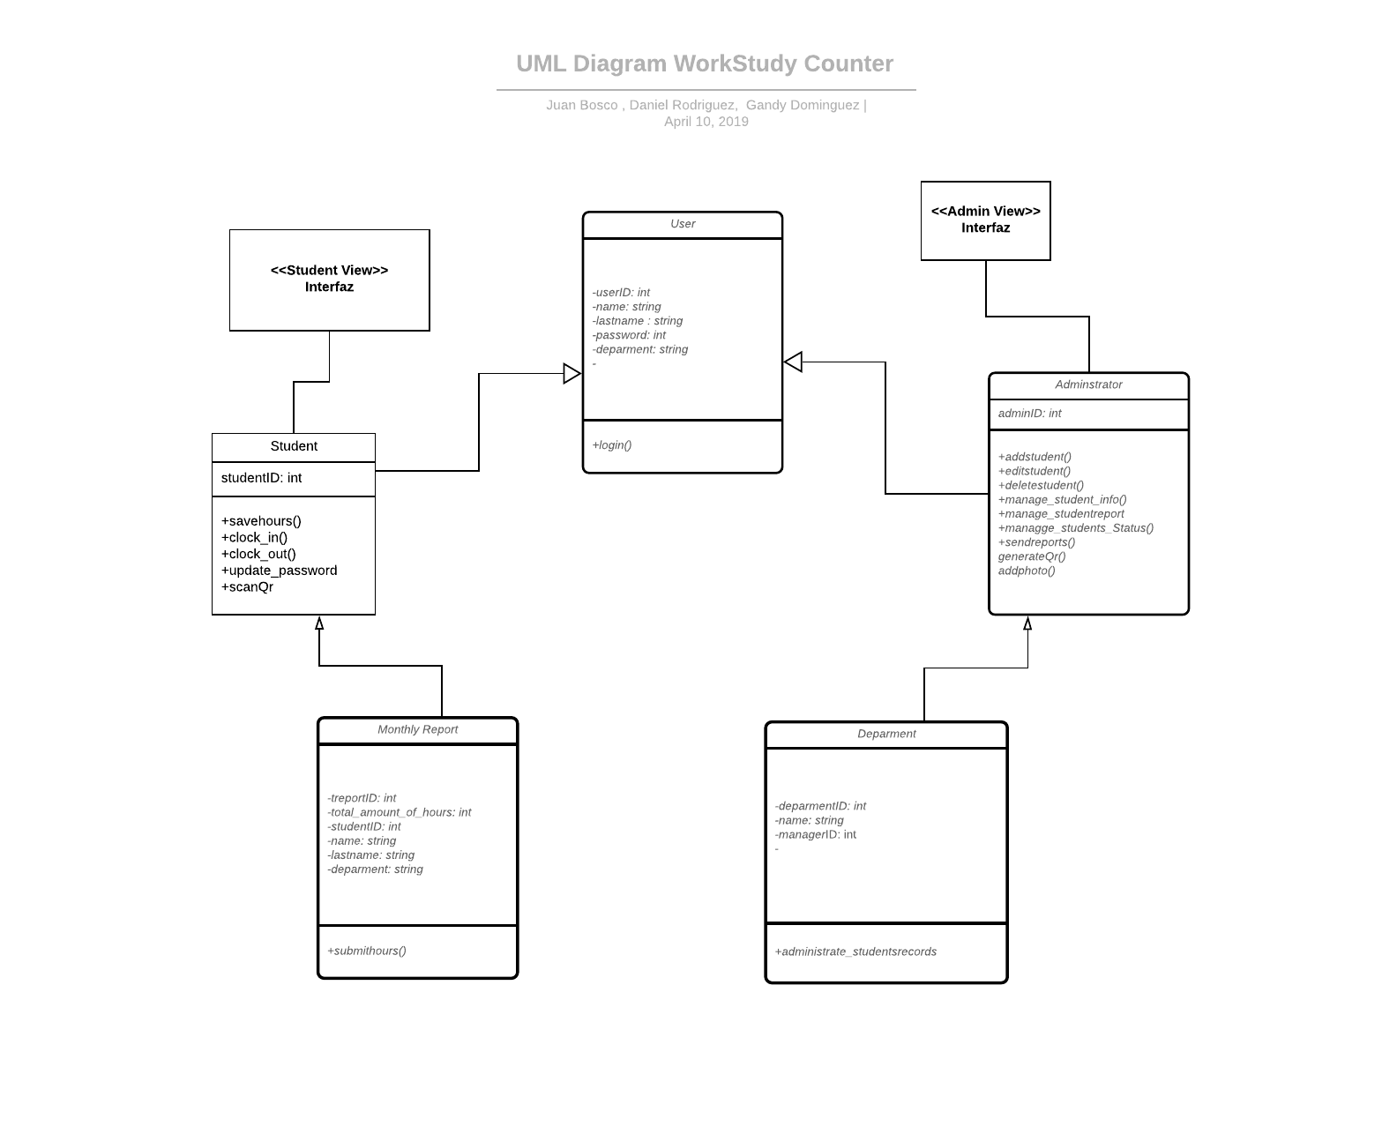

## Implementation Diagram

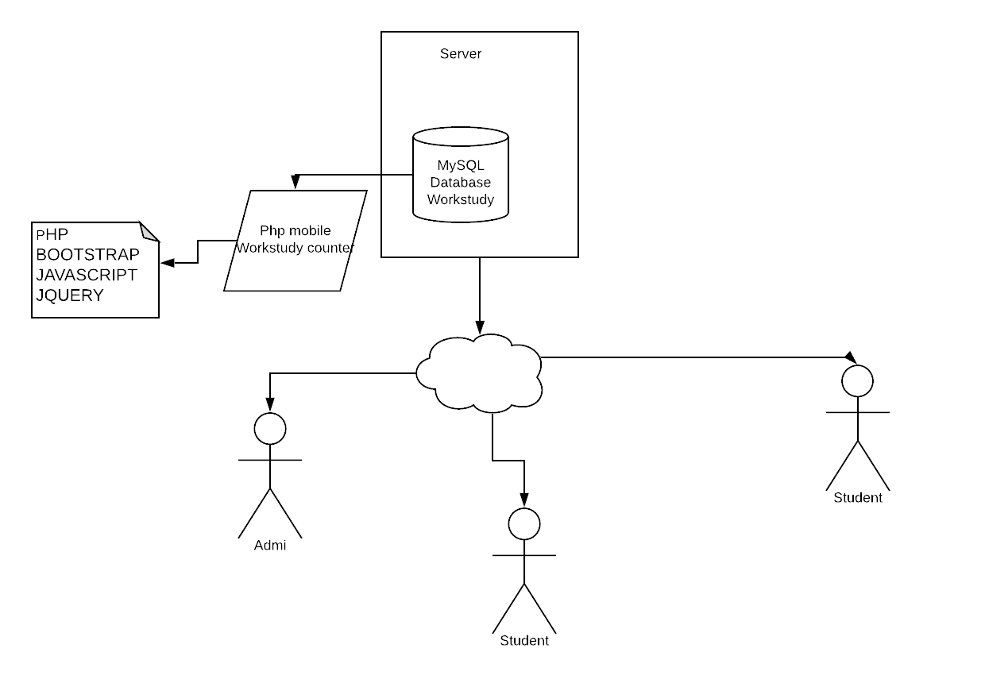

## Relevant things about code

## Every section it is divided by folder, that contains the piece of codes that end up in this fully functional project. The main programing language we use was PHP. Also, we complement the website with CSS and HTML for the design. Additionally, many of our components require the use of JavaScript. The use of template was another indispensable thing we used, mainly for the design. Bootstrap was one of our components, basically the most popular framework for building this responsive site. The website also let the user manage the data and download reports in other works it is a 100% user-interactive.

## Required instructions for installation

1. Install a Database software such as MySQL Workbench
2. Create the Workstudy DataBase in MySQL or in PHPMyAdmin
3. Restore backup workstudy.sql DB in PHPMyAdmin
4. Install Xampp
5. create a public folder called Workstudy in the route: C:\xampp\htdocs\
6. Download the Zip file from the Github repository
7. Decompress the files in the folder: C:\xampp\htdocs\Workstudy\
8. Start Xampp
9. Turn on MySQL and Apache ports
10. Go to localhost/workstudy
11. Start using the Work-Study Counter

## General recommendations for system maintenance

There are some steps to follow in order to ensure that the software will continue fully functional. Every Software has its own life cycle. This project can be updated manually.

* The software will need a cloud-based solution eventually. Now can work perfectly with a web-based solution. The web browser relies on the web server components installed on backend infrastructure systems for the heavy lifting in providing its core functional web services.
* There are other steps to have in mind, as the project evolves, will be necessary to change the design.
* Improve the design, to make the website usable in every environment. Adapting the software will be very important if the software is meant to use in a work environment.
* Implement Enhancement, for this step, will be indispensable to run some test in order to select the area where the project needs some improvements
* Interface with other systems, adapt the program so that different software facilities can be used. This will be very helpful if the administrator wants to add another secondary software.
* User training, although the program is not complex, will require some knowledge of the administrator to manage the database
* Create a maintenance planning activity in order to recollect all the data store in the website
* Recollect feedback of the users, we also include a public view report to recollect this data
* Add different tools, as the program evolve it is going to be necessary to have an analytical third-party app. A software Maintenance tool will be very helpful, there are several criteria to choose the correct tool, feature, cost-benefits, easy to use, etc.

## Conclusion

This program is designed for all the students at Keiser University who are in the work-study program. This website allows students and users to maintain their daily records. And, for those who just want to look around, we offer a public view. This public view is focused on the new activities that is coming soon.

As we mentioned before, the project purpose is to let the students feel confident that their hours will be delivered on time; there will be no deduction of the hours.

It is a simple yet effective web-based time clock system. It allows you to track all users time. An administration view is included, to add or delete users, change a user's password and hide the reports from your users.

The three main goals of this project are:

1. Provide a simple mechanism for users in order to interact with the functions that the website offers.
2. Create a full automatized process to record the time of each student
3. The system shouldn’t require any extra effort on the part of any other admin who wants to run the website